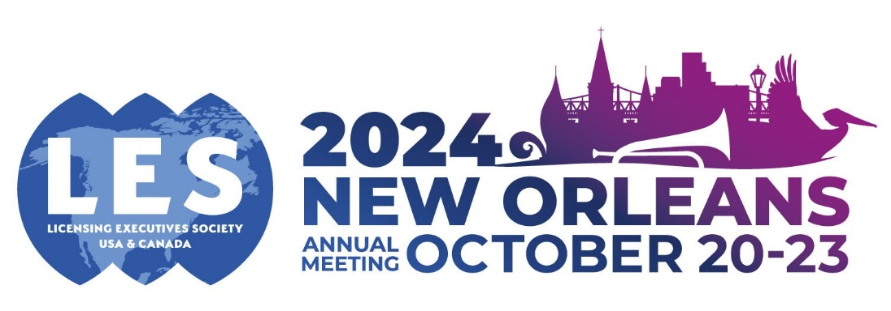

Call for Proposals for LES AM 2024 – Workshop

Workshops will last 60 mins with up to 4 speakers.

Please use all of the following headings to format your submission - delete all text in red before submitting.

Workshop title:

Topic
Workshop overall summary: (up to 350 words)

Suggested Moderator and/or Speakers
(up to 4 speakers
+ moderator max):
Full Name, title, company, and email address

Session Abstract (up to 350 words):

_______
Other information:

Related Papers or articles previously published (if relevant):

Related Sessions at previous LES meetings (if relevant)

Please note ALL accepted speakers will be required to complete a speaker agreement form, register, and pay to attend the Annual Meeting by 1st April 2024. (guaranteed early bird registration rate)

